Coassemble Reports
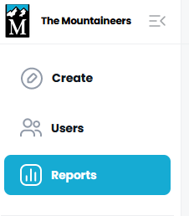

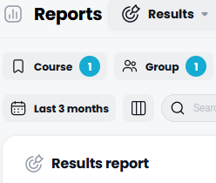
Results
To use, filter for course and group.
Features:
- Export to CSV
- View modules completed and assignments accepted
Drawbacks:
- No user sort
- No drill down or visibility to assignments

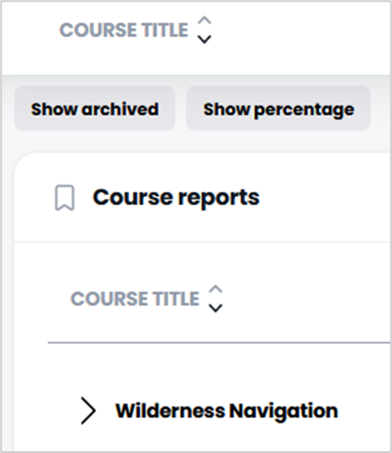
Course
To use, find and expand your course and select group to see users.
Features:
- Course progress summary for group
- Sort by user name
- Some assignments are viewable by clicking
- Module shows completion date as check against broken completion summary percentage at bottom and on reporting
Drawbacks:
- Export doesn’t work all the time
- Some assignments are NOT viewable by clicking

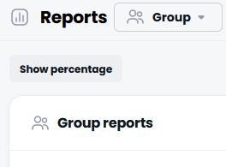
Group
To use, click on group name.
Features:
- Group progress summary for courses
- Sort by user name
- Some assignments are viewable by clicking
- Module shows completion date as check against broken completion summary percentage at bottom and on reporting
Drawbacks:
- Some assignments are NOT viewable by clicking

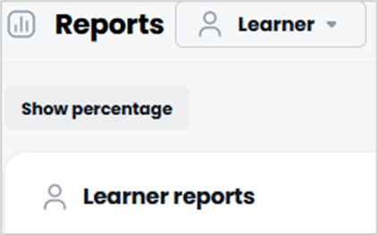
Learner
To use, find the learner
Features:
- Sort by user name
- Similar detail to other details by user
Drawbacks:
- Every learner in the system is included, so not useful for monitoring one group or one course

